- Name – Prajwal
- USN – 1NT24EC104
- Sem & Sec – 4th Sem & ECE – C section

1.Python Versions Installations:

- Code and Output:
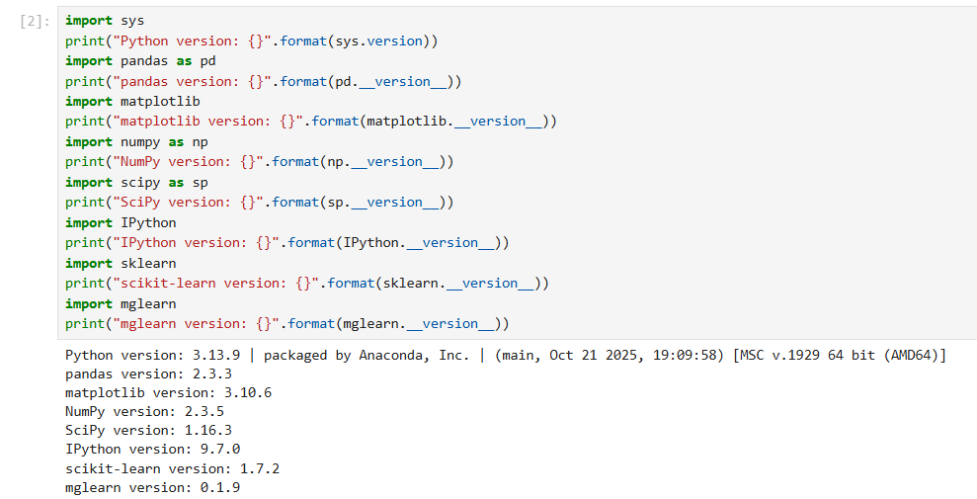

2.Iris dataset Analysis:

- Code:
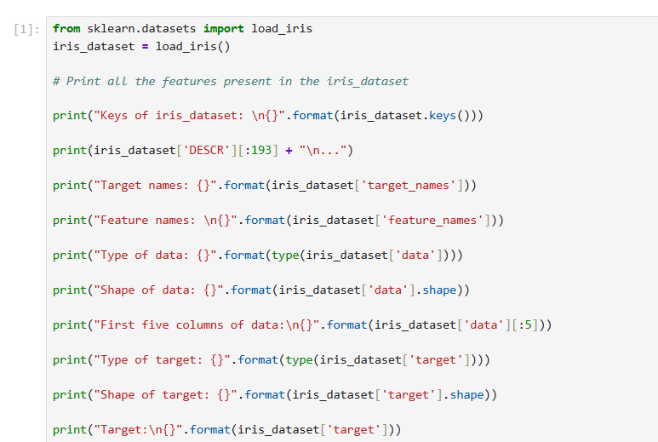

-Output:
